**Index Trade Setups**

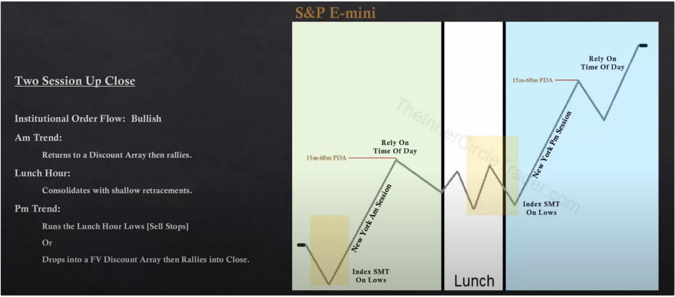Dont overcomplicate it, it needs to be simple Two session up close

In the PM session it could fall short first of the 15m or 1h premium array and then later on still go to it, when that happens look for longs to trade into the premium array

Two session down close

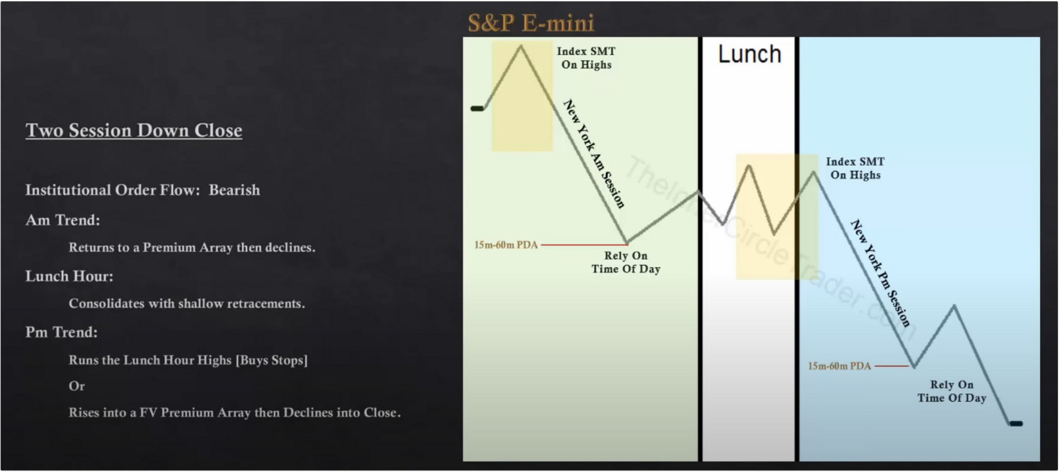

AM session should reach into a premium array and have SMT between high in the timespan 5am to 930

Rely on time of day to get the maximum amount of range

For New York lunch SMT you look at the highs during lunch hour and the high that forms post New York lunch

PM trend: how to know which one will happen? I guess if Lunch hour reached into a premium array already then theres no need for PM session to do it? Test it

Ideally would be holding to the bond close

If the bounce at the end of the PM session is not at a logical 15m or 1h discount array then hold

and wait for it to break another leg lower

Am rally Pm reversal

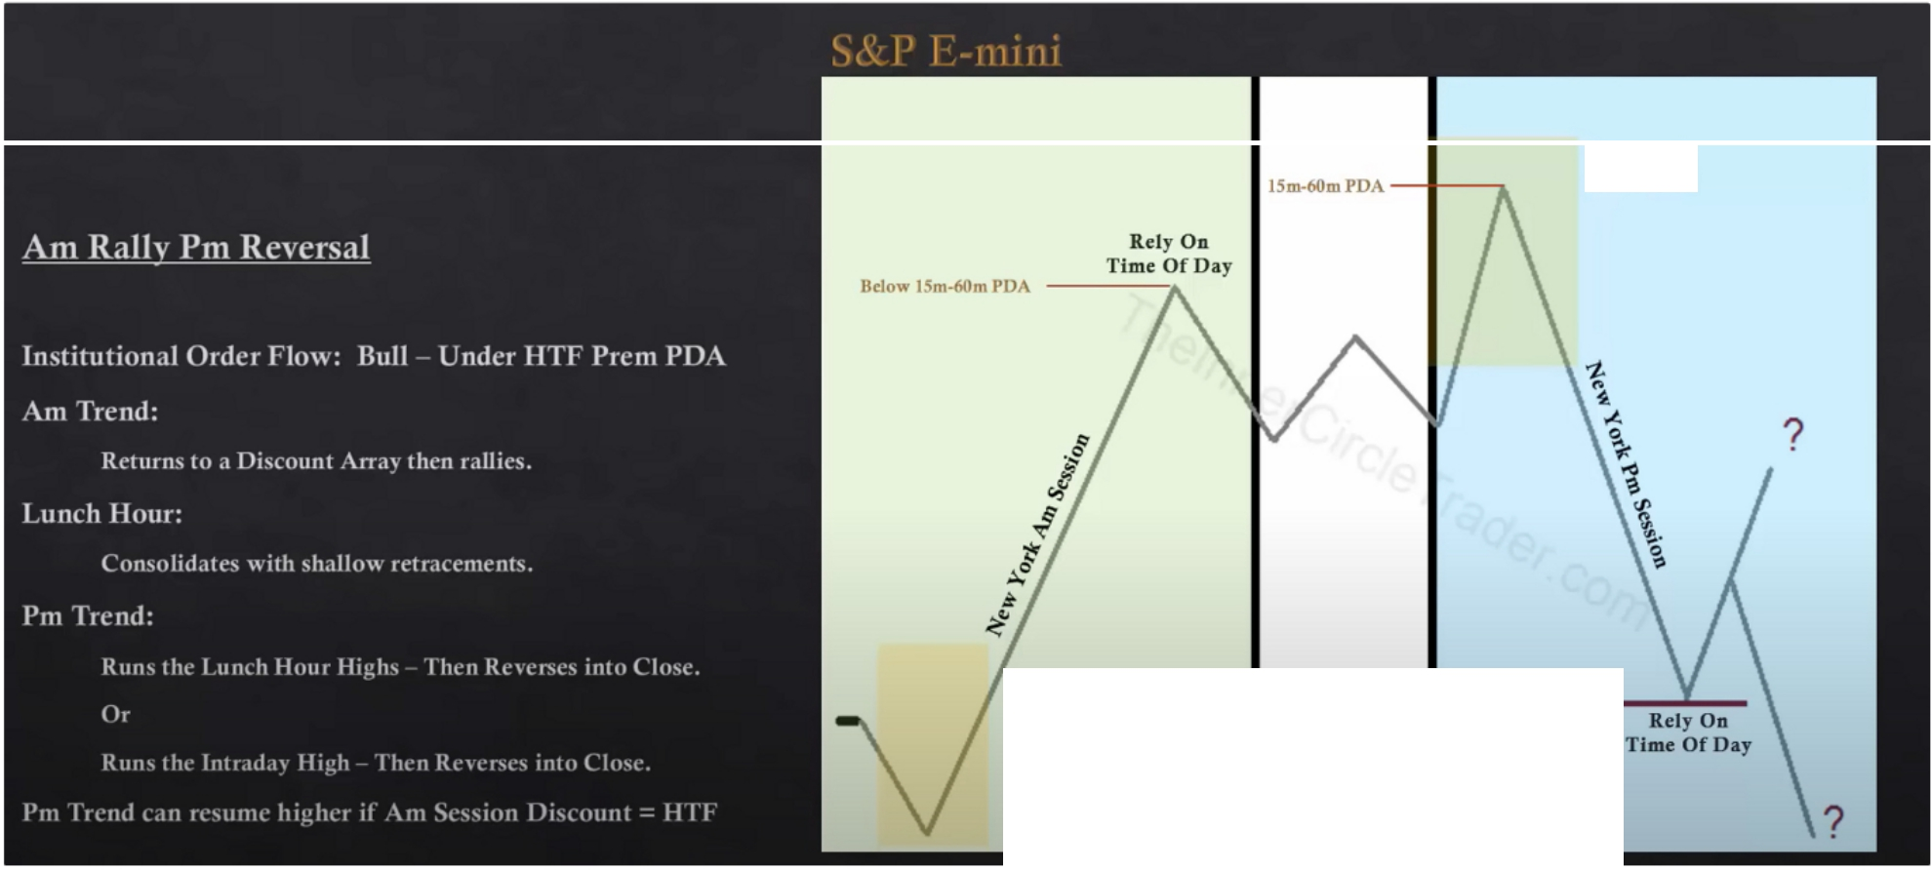

**Index SMT On Highs**

**lades SMT On Lows**

**Lunch**

But the 15m and 1h is not HTF? Correct but were going to looking for an overlapping premium arrays thats nested within a 4h or daily premium array

If the AM session already reached into the premium array and its being protected then again dont expect the PM session to spike up above the AM session high

Am decline Pm reversal

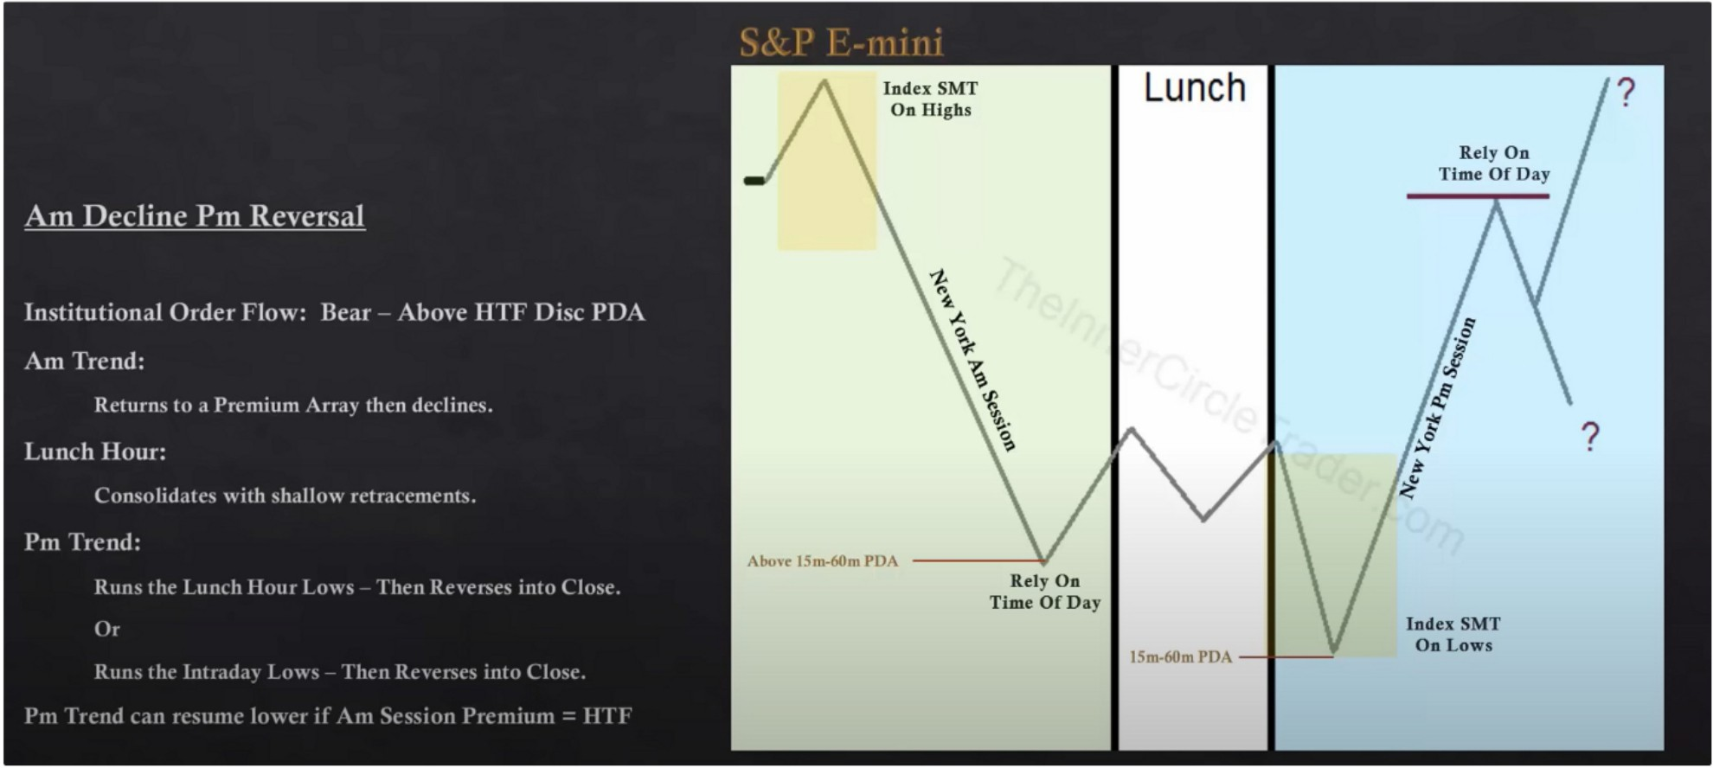

Consolidation Am decline Pm rally

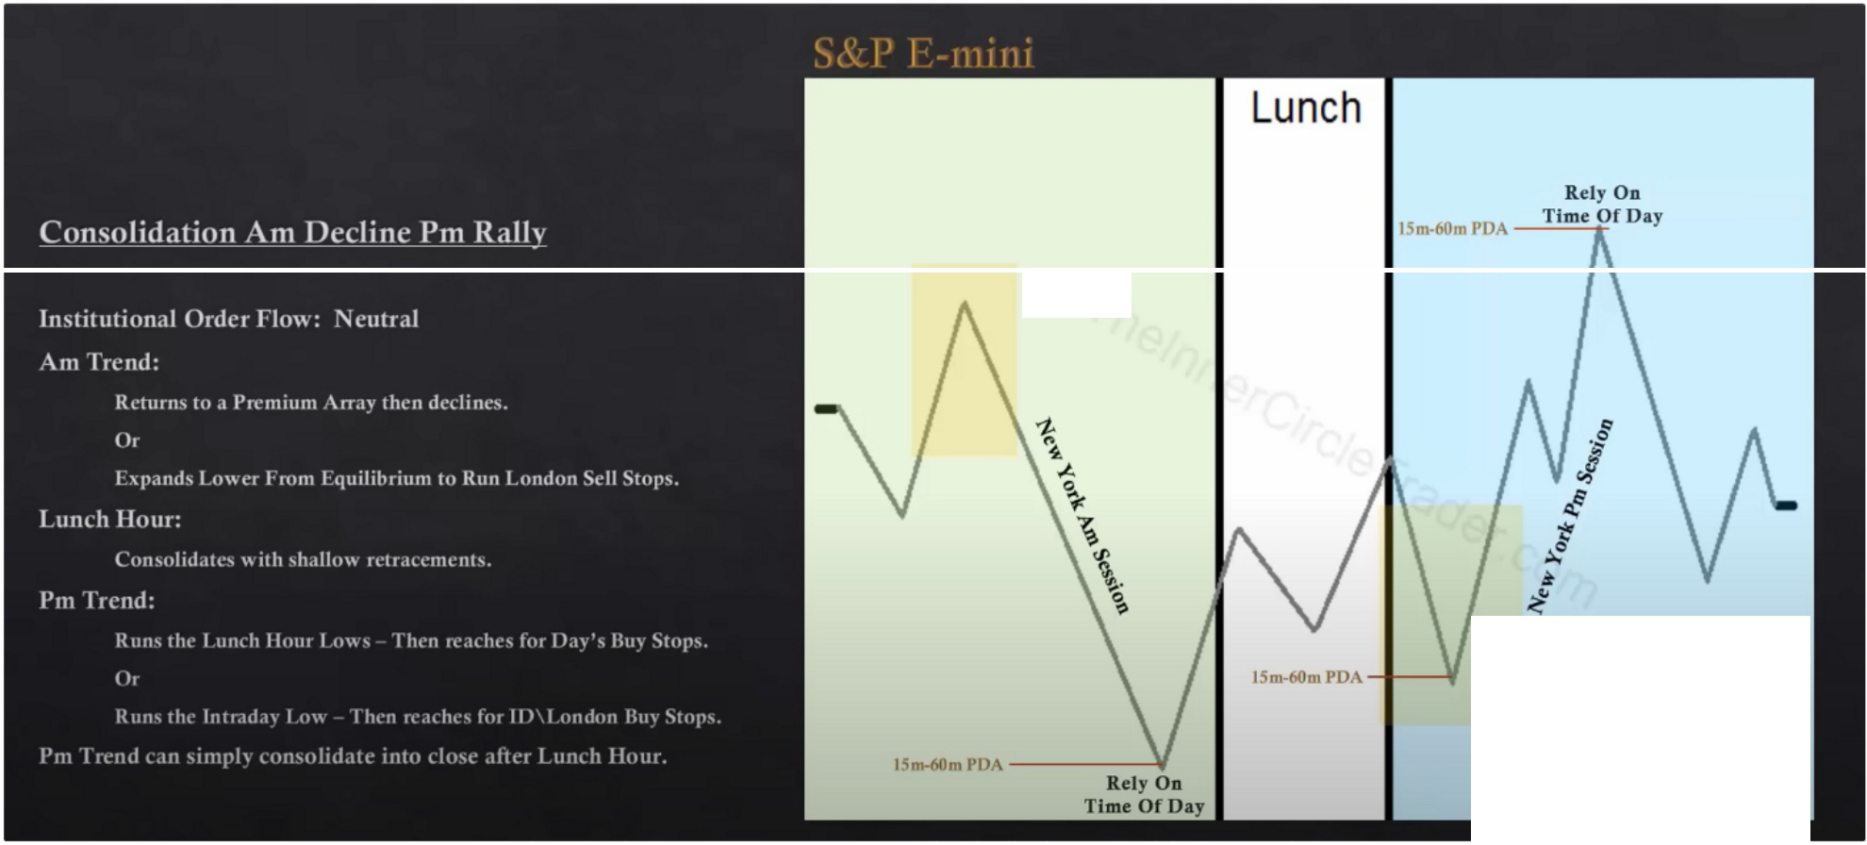

**Index SMT**

**On Highs**

**Index SMT**

**On Lows**

We wont be holding to the end of day on this one, generally there will be a short term high forming at around 2pm and it will decline into the close into the EQ price point of the day

The PM session low can run the lunch low and or the AM session low, you can determine that by if the AM session bounced of a nested 15m or 1h nested level discount array in a 4h or daily discount array then we dont expect it to get taken out, if the AM session just fell short then we would expect the PM session to reach for the 4h or daily discount array

Consolidation Am rally Pm decline

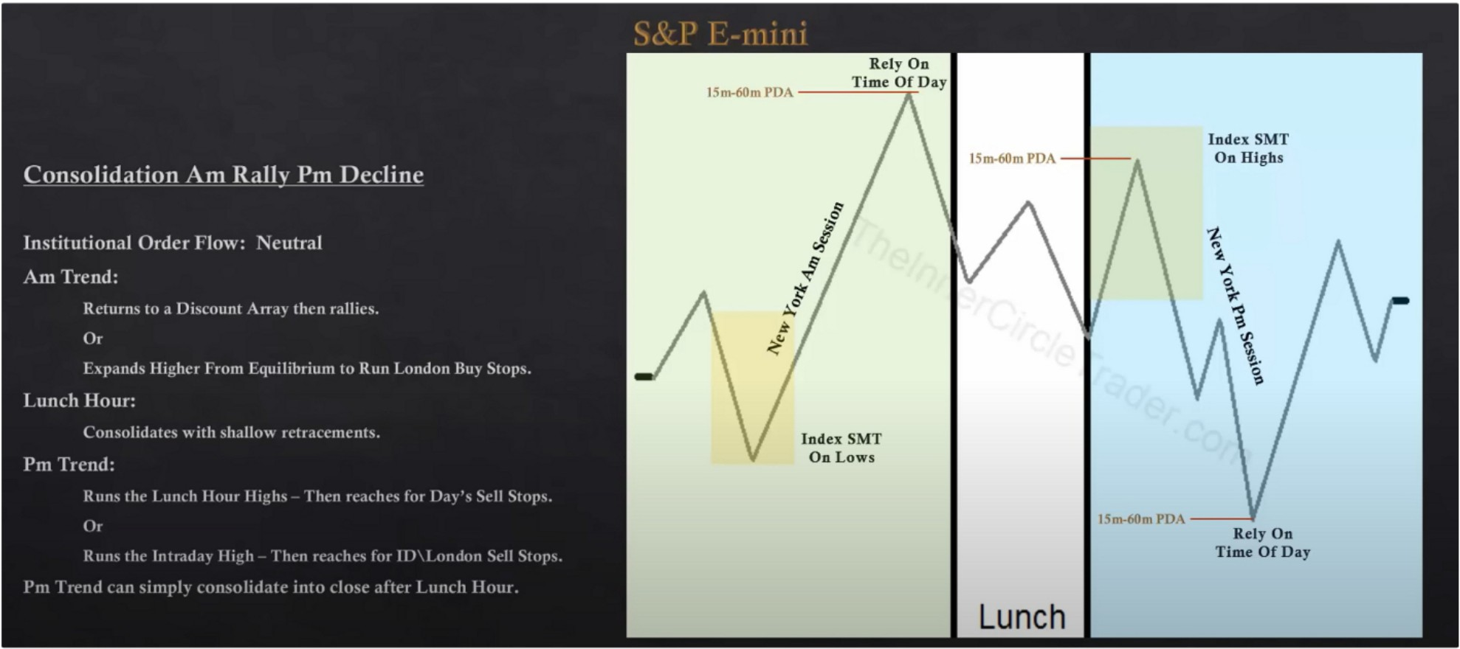

Ask yourself what caused the high to form? Is it falling short of a 4h or daily premium array? Or did it already reach it?

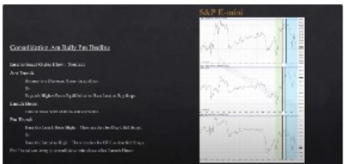

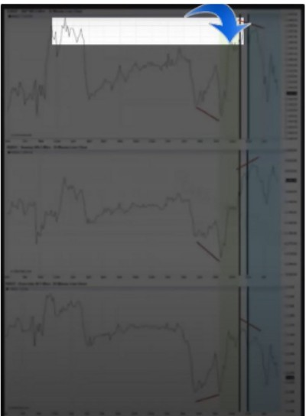In august month 12 he will give flowcharts on how to trade these

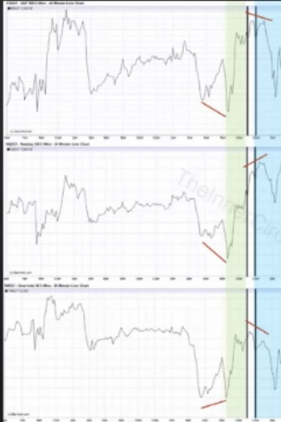

If a day is bullish and the market rallies all AM session, then the PM session will seek sellside under AM session lows and reprice to any BISI (Buyside imbalance sellside inefficiency) once it is there expect a return to premium inside the range.

Arjo I Twitter, lnstagram I Linktree

Linktree. Make your link do more.

I https://t.co/HhmmTN1fUI

JavaScript is not available.

*"JI* https://twitter.com/arjoio